STANDARD FORMAT OF “LEHENGA DESCRIPTION”


For Online Selling Products
Design Name: MODERN-A
Product Colours NO.: A2
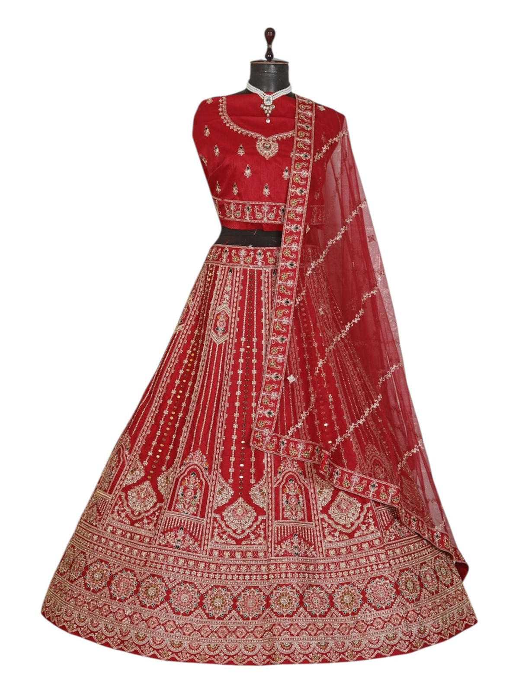.
Particulars | Details
Lehenga Fabric | Italian Silk
Blouse Fabric | Italian Silk
Dupatta Fabric | Net
Work Type | Jari, Jarkan & Thread embroidery Work
Colour | Red
Pattern | Bridal Designer Lehenga
Stitching Type | Semi-Stitched (Can be customized up to 44")
Occasion | Wedding, Reception, Engagement & Festive Wear
Fit Type | Regular Fit
Care Instructions | Dry Clean Only
Package Contents | 1 Lehenga, 1 Blouse Piece, 1 Dupatta

KEY HIGHLIGHTS
- Made from premium Italian silk fabric for a smooth and elegant drape
- Decorated with intricate Jari, Jarkan & thread embroidery
- Comes with a soft net dupatta to complete the bridal look
- Ideal for weddings, receptions, and grand festive functions
- Semi-stitched design allows easy customization for perfect fitting
- Lightweight fabric ensures comfort during long wedding events
- Blends modern bridal fashion with traditional handcrafted detailing

